Sign-Bridge
Final Year Project Proposal

Session 2023-2027

A project submitted in partial fulfillment of the
COMSATS University Degree
of
BS in Computer Science / Software Engineering (CUI)



Department of Computer Science
COMSATS University Islamabad, Lahore Campus

Project Registration
Project ID (for office use)
Type of project |  |  | [ ] Traditional [ ] Industrial [ ] Continuing
Nature of project |  |  | [ ] Development [ ] Research & Development
Sustainable Development Goals(SDGs) |  |  | [ ] Good Health and Well-Being [] Quality Education  [ ] Industry, Innovation, and Infrastructure [ ] Gender Equality  [ ] Decent Work and Economic Growth [ ] Climate Action
Area of specialization |  |  | [ ] Artificial Intelligence (AI) [ ] Blockchain [ ] Cybersecurity  [ ] Data Science and Analytics [ ] Game Development  [ ] Internet of Things (IoT) [ ] Natural Language Processing (NLP)  [ ] Mobile App Development [ ] Web Development
Project Group Members
Sr.# | Reg. # | Student Name |  | Email ID | Phone # | Signature
(i) | SP23-BCS-008 | Abdur Rehman Zubair |  | sp23-bcs-008@cuilahore.edu.pk | +92 308 6511159
(ii) | SP23-BCS-149 | Mehroz Sajjad |  | sp23-bcs-149@cuilahore.edu.pk | +92 327 7622428
(iii) | SP23-BCS-039 | Bushra Jabbar |  | sp23-bcs-039@cuilahore.edu.pk | +92 330 4241701
Declaration: FYP group members have cleared all prerequisite courses For FYP-I as per their degree requirements.
For BS(Computer Science) and BS(Software Engineering)
(CSC241 Object Oriented Programming, CSC291 Software Engineering Concepts, CSC270 Database Systems, HUM102 Report Writing Skills)
For BS(Artficial Intelligence)
(CSC291 Software Engineering Concepts, HUM102 Report Writing Skills)

Plagiarism Free Certificate
This will be to certify that, I am Abdur Rehman Zubair S/D/o Mohammad Zubair , group leader of FYP under registration no CUI /SP23-BCS-008/LHR at the Computer Science Department, COMSATS University Islamabad, Lahore Campus. I declare that my FYP proposal will be checked by my supervisor and the similarity index will be ________% that will be less than 20%, an acceptable limit by HEC. The report will be attached herewith as Appendix A.
Date: 8 Oct 20025 Name of Group Leader: Abdur Rehman Zubair Signature: __________
Name of Supervisor: Sir Usama Ijaz Bajwa Co Supervisor (if any): Sir Amaid Zia
Designation: _____________________ Designation: _____________________
Signature: _____________________ Signature: _____________________

ABSTRACT
This project will aim to develop SignBridge, a real-time mobile application designed to facilitate communication between the deaf/mute community and non-signers. Existing systems for sign language translation will be mostly web-based and experience high latency and limited accessibility. The proposed system will allow users to input data through video, text, or audio and receive an accurate output in the desired mode—text, sign animation, or symbols. Similarly, sign language videos can be translated into English text using deep learning-based gesture and motion recognition models. The project will integrate computer vision, natural language processing, and machine learning techniques into a cross-platform mobile app framework to achieve low latency and high performance. Expected outcomes include a fast, user-friendly application that bridges communication barriers and sets a foundation for inclusive technology in real-time sign language translation.

TABLE OF CONTENTS
- Introduction .................................................................................................................. 6
1.1 Domain Background .................................................................................... 6
1.2 Motivation and Significance ......................................................................... 6
1.3 Objectives and Scope ................................................................................... 6
1.4 Proposed Solution ......................................................................................... 7
1.5 Expected Results or Outcomes ........................................................................... 7
- Problem Statement ................................................................................................. 8
- Project Objectives .................................................................................................. 8
- Related Work .......................................................................................................... 8
4.1 Model and Algorithm Development .............................................................. 8
4.2 Limitations in Current Literature .................................................................. 9
4.3 How Prior Work Informs This Project ....................................................... 9
- Proposed Methodology and Architecture ......................................................... 9
5.1 High-level Architecture (Modules) .............................................................. 9
5.2 Detailed Step-by-Step Methodology .......................................................... 11
- Success Criterion .................................................................................................... 12
- Team Activities ....................................................................................................... 12
- Tools & Libraries ................................................................................................... 15
- References ............................................................................................................... 15

1. INTRODUCTION
1.1 Domain Background
Sign language serves as a fundamental and comprehensive mode of communication for individuals with hearing or speech impairments, relying on a complex system of hand gestures, facial expressions, and body movements. This system has evolved into diverse, structured linguistic systems globally, such as American Sign Language (ASL), British Sign Language (BSL), and Pakistan Sign Language (PSL). With the increasing adoption of digital communication, there will be a critical and growing need for technology to bridge the communication gap between the deaf/mute community and non-signers. Traditional communication relies heavily on human interpreters or limited manual dictionaries, which will be often time-consuming, expensive, and generally inaccessible for spontaneous, daily interactions.
Recent years have seen transformative advancements in Artificial Intelligence (AI), particularly Computer Vision (CV), and Natural Language Processing (NLP), which have opened new pathways for automated sign language translation. Deep learning algorithms, such as those based on Convolutional Neural Networks (CNNs) and Recurrent Neural Networks (RNNs), have demonstrated the ability to accurately recognize gestures and translate them into text or speech. However, current systems, which will be often proof-of-concept or limited web-based solutions (like older -based models or experimental projects), face significant practical challenges. These limitations include high latency (making real-time conversation difficult), reliance on stable hardware and internet connection, and a critical lack of mobile adaptability necessary for genuine daily use. Furthermore, many existing models struggle with variations in lighting, background clutter, and the computational complexity required for simultaneous pose estimation.
1.2 Motivation and Significance
The primary motivation behind this project will be the pressing societal need to enhance accessibility and inclusivity through robust technology. Communication barriers severely impact the quality of life, access to education, and employment opportunities for the deaf/mute population. According to the World Health Organization (WHO), over 430 million people worldwide suffer from disabling hearing loss. The tools currently available to this large community remain largely underdeveloped and inadequately optimized for real-world speed and convenience. Existing systems, while proving the concept of automation will be possible, will be not yet efficient or responsive enough for seamless, real-time social or professional interaction.
Our team will be dedicated to designing and implementing SignBridge, a dedicated mobile-based, real-time system that leverages state-of-the-art models. By shifting the translation paradigm from web platforms to a dedicated, cross-platform mobile application, we aim to provide significantly faster processing, potential offline capability, and a vastly improved user experience. This project aligns directly with Sustainable Development Goals (SDG 4: Quality Education) and (SDG 9: Industry, Innovation, and Infrastructure), contributing a tangible step toward technological inclusivity and social benefit for a marginalized community.
1.3 Objectives and Scope
The main goal of this project will be to develop and implement SignBridge, a functional mobile application capable of performing bidirectional sign language translation—from sign language video to text/audio, and from English text/audio to sign animation or symbols. The system will support three flexible input modes: video, text, and audio. The specific objectives and scope of the project cover:
    - Development of a Lightweight Gesture Recognition Model: Implementing an optimized deep learning model, likely combining CNNs (such as a highly efficient MobileNet architecture) for spatial feature extraction and LSTMs (Long Short-Term Memory Networks) for temporal sequence modeling, to achieve high accuracy with minimal computational overhead.
    - Integration of NLP and TTS Modules: Incorporating models for robust English text processing and a Text-to-Speech (TTS) module for audio generation to support two-way communication.
    - Design of an Intuitive Mobile Interface: Creating an -designed, user-friendly interface using Flutter for maximum accessibility and ease of use, suitable for diverse age groups and technical backgrounds.
    - Implementation of a Modular Backend: Developing a robust service using FastAPI to manage real-time data exchange, model inference requests, user sessions, and database logging.
The project will focus its proof-of-concept on English text and PSL gestures and will specifically exclude multi-language sign systems, advanced animated avatars, and full conversational dialogue systems at this initial stage.
1.4 Proposed Solution
The proposed solution, SignBridge, will be a cross-platform mobile application that directly addresses the limitations of existing systems. Its core will be a modular architecture designed for speed and reliability:
    - Frontend Layer: Built using Flutter for native performance on both and , responsible for capturing camera input and rendering translation outputs (text, audio, sign animation).
    - Machine Learning Layer: The core translation engine, where models will be trained using frameworks like or . Crucially, the models will be optimized using a mobile-friendly runtime such as TensorFlow Lite to facilitate on-device or near-edge processing, minimizing server communication latency.
    - Backend Layer: A robust layer (e.g., using FastAPI) handling secure data transmission, user authentication, and serving model predictions when cloud processing will be required.
    - Database Layer: Utilizing a flexible NoSQL database like MongoDB or for storing sign mappings, user data, and system logs, ensuring scalability.
By leveraging TensorFlow Lite and a dedicated mobile framework, SignBridge will be uniquely positioned to ensure low latency and cross-platform compatibility, directly solving the high latency and web dependency issues of current approaches.
1.5 Expected Results or Outcomes
The successful outcome of this project will be a fully functional, highly performant SignBridge mobile application prototype capable of accurately interpreting sign gestures and generating corresponding English text or speech in real-time. The system will demonstrably perform the reverse translation as well. The final deliverable will be supported by a comprehensive evaluation report to prove the project's success using objective, measurable criteria:
    - Technical Success Metrics: Achieving a sign-to-text translation accuracy of on a standardized, held-out test set, and demonstrating real-time performance by maintaining an average frame-to-text translation latency of milliseconds.
    - Deliverables: A fully operational mobile application prototype, complete source code, a documented dataset integration plan, and the final evaluation report.
Beyond the technical deliverables, this project will be expected to contribute a valuable open-source asset toward digital inclusion and assistive technology, enabling significantly smoother and more independent communication between the deaf/mute community and the general population.

2. PROBLEM STATEMENT
Despite recent advancements in artificial intelligence and computer vision, real-time sign language translation systems remain inefficient, particularly in mobile environments. Existing web-based applications suffer from high latency, limited offline functionality, and poor scalability, making them impractical for everyday use. Moreover, many systems will be unidirectional, supporting only sign-to-text or text-to-sign translation rather than both. There will be a critical need for a fast, mobile-based, bidirectional sign language translation application that leverages modern ML and NLP techniques to deliver accurate, low-latency, and accessible communication between deaf/mute individuals and non-signers.

3. PROJECT OBJECTIVES
- To collect and preprocess a relevant sign language dataset (video/image sequences).
- To develop a real-time, bidirectional sign-to-text and text-to-sign translation system.
- To design and train deep learning and NLP models for gesture and text recognition.
- To build and integrate a backend and mobile frontend for seamless communication.
- To evaluate system performance based on accuracy, response time, and usability.
- To promote accessibility and inclusivity through technology aligned with SDGs.

4.RELATED WORK
Automated Sign Language Recognition (SLR) and Translation have progressed rapidly over the last decade, evolving from sensor/glove-based prototypes to vision-based deep-learning systems that operate on RGB video and skeleton/keypoint data. Recent survey articles show a broad shift: earlier systems focused on hand-crafted features and wearables, while modern systems rely on deep convolutional and sequence models, skeleton-based graph networks, and end-to-end translation pipelines combining vision and language models. These surveys summarize the state-of-the-art methods, datasets, and key challenges (data scarcity, temporal segmentation, signer variability, real-time inference). ScienceDirect+1
Datasets and benchmarks have driven much of the progress. Word-level datasets (e.g., WLASL) and continuous/translation corpora (e.g., RWTH-PHOENIX) provide the scale required for deep learning experiments and make evaluation more reproducible; large lexicon datasets such as ASLLVD and WLASL will be widely used for isolated-word recognition while RWTH-PHOENIX serves as a benchmark for continuous sign recognition and sign-to-text translation. These datasets expose typical SLR challenges like inter-signer variation, background clutter, and long temporal sequences.
  - Model and algorithm development has followed multiple complementary paths:

    - Appearance-based models (video frame → CNN / 3D-CNN): These methods learn features directly from RGB frames (2D CNNs, 3D CNNs, and I3D-style architectures) and will be effective when visual appearance (handshape, object presence, clothing) will be informative. They tend to require large amounts of labeled video to generalize well.

    - Skeleton / keypoint-based models (pose → graph networks): Using pose or hand-joint landmarks reduces appearance variation and will focus learning on motion and relative articulation. Spatial-Temporal Graph Convolutional Networks (ST-GCN) and related graph-based models have shown strong results by modeling joints as graph nodes and applying temporal convolutions across frames. These approaches often perform well in signer-independent scenarios and will be computationally attractive when using lightweight keypoint extractors first.

    - Sequence-to-sequence translation approaches: For sign-to-text translation, researchers have adapted neural machine translation ideas (encoder–decoder with attention) to convert sign sequences (frames or glosses) into text sentences. Camgö z et al.’s work on neural sign language translation will be a notable early demonstration of seq2seq methods for SLR and sign-to-text translation.

    - Large pre-trained vision–language models & adapters: Recent work explores using large vision-language backbones and lightweight adapters to handle sign language tasks despite dataset limitations—interfacing visual representations with language models to produce glosses or translations. This direction will be promising for improving semantics-aware translation even with limited annotated sign data.
Tooling and on-device capabilities have improved practical deployment options. Libraries like Google’s MediaPipe provide efficient hand- and pose-landmark detection with mobile-friendly runtimes, making real-time keypoint extraction feasible on phones. Similarly, TensorFlow Lite (LiteRT) and PyTorch Mobile provide conversions and optimizations (quantization, pruning) targeted at low-latency, on-device inference—crucial if the goal will be to move from slow web-hosted demos to responsive mobile apps.
  - Limitations
Limitations in the current literature that motivate this project include: (a) many publicly available systems will be unidirectional (either sign→text or text→sign) rather than true bidirectional communication platforms; (b) web-based demos often suffer higher round-trip latency and require stable network connectivity, harming real-time usability; (c) many research solutions focus on high-resource languages (ASL, DGS) and do not generalize well to under-resourced sign languages; and (d) few academic prototypes prioritize mobile optimizations needed for low-latency, offline use. These gaps indicate a practical need for a cross-platform mobile application that will integrate the best of keypoint-based efficiency and appearance-based expressivity, paired with translation modules and on-device optimizations.
  - How prior work informs this project:
This project will combine successful ideas from prior work—use MediaPipe/OpenPose for keypoint extraction to reduce input noise and computational load, use skeleton-graph models (ST-GCN) where appropriate for motion modeling, and adopt seq2seq or transformer-style translation modules for sign→text generation. For mobile deployment we will convert and optimize models using TensorFlow Lite (LiteRT) and follow on-device model optimization best practices to keep latency low. These design choices directly respond to the gaps identified in the literature. arXiv+2CVF Open Access+2

5. PROPOSED METHODOLOGY AND ARCHITECTURE
Below will be a clear, step-by-step methodology and architecture plan you can include in the proposal. It describes modules, algorithms, training & evaluation approach, and deployment considerations.
  - High-level architecture (modules)

    - Input Layer (Mobile UI)
  - Accepts video (camera), text (keyboard), and audio (mic).
  - Responsible for capture, basic validation, and local buffering.
    - Preprocessing & Feature Extraction
  - Video → frames → run hand & pose landmark extractor (MediaPipe/OpenPose) to get 2D/3D joint/keypoint series. MediaPipe
  - Audio → speech-to-text using an on-device or cloud ASR (start with local model or use native mobile STT APIs if available).
  - Text → tokenization / normalization.
    - Core ML/NLP Layer (Models)
  - Gesture Recognition Model(s): two parallel strategies can be used and later fused:
a. Skeleton-based model (ST-GCN or GCN variants) for sequences of keypoints to detect/recognize signs in a signer-agnostic way. arXiv
b. Appearance-based model (3D-CNN / I3D / CNN+Temporal module or short transformer) to capture subtle shape/facial cues where necessary. CVF Open Access
  - Sequence / Translation model: encoder–decoder (attention) or transformer-based module to convert recognized sign sequences (or glosses) into fluent English sentences; follows architectures used in sign→text translation literature. CVF Open Access
  - Fusion & Confidence: combine outputs from skeleton and appearance branches (e.g., weighted averaging or a small fusion network), attach confidence score.
    - Output Layer
  - Sign → Text/Audio: display recognized English text; optionally synthesize speech via TTS.
  - Text/Audio → Sign: map English words/phrases to a symbolic sign set and render either (a) pre-recorded short sign clips / symbol icons, or (b) simple 2D animation sequence (for prototype). For future/extended work a 3D avatar could be considered (out of scope for this year).
5.1.5 Backend & Storage
  - A lightweight API (FastAPI / Node.js) for optional cloud inference, model serving, and user data (if online features will be required). For on-device-first approach, backend primarily handles analytics, user preferences, and optional heavy-batch model updates. Use Firebase or MongoDB for storage of logs and user preferences.
    - Mobile Integration & Optimization
  - Convert final trained models to TensorFlow Lite / LiteRT (or PyTorch Mobile) and apply quantization/ pruning and delegate acceleration (NNAPI, GPU delegate) to reduce latency and memory. TensorFlow+1
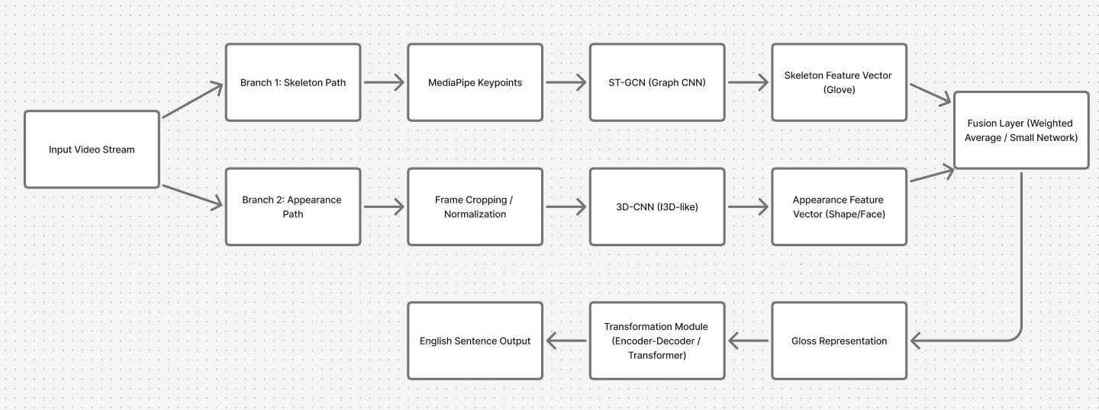

Figure 1. System Flow Architecture

5.2 Detailed step-by-step methodology
    - Phase A — Data & Preprocessing

- Dataset selection / creation: evaluate public datasets (WLASL, ASLLVD, RWTH-PHOENIX) for baseline training and augment with custom recordings if PSL or local signs will be required.
- Annotation & labeling: for translation tasks include gloss-level alignment if possible (use PHOENIX-style parallel corpora).
- Preprocessing: frame extraction, normalization, hand/pose landmark extraction (MediaPipe), temporal windowing, per-frame normalization, and augmentation (flip, scale, temporal jitter). MediaPipe

    - Phase B — Model Prototyping & Training

- Skeleton branch: train ST-GCN on keypoint sequences (skeleton representation). Experiment with temporal receptive field and graph construction (hands-only vs full-body). arXiv
- Appearance branch: train a lightweight 3D-CNN (I3D-like) or 2D CNN + temporal aggregator (e.g., CNN + LSTM or small transformer). Use transfer
learning to accelerate convergence. CVF Open Access
- Translation module: train an encoder-decoder (attention) or transformer to map sign representation (gloss or high-level embedding) → English sentence. Evaluate using BLEU and WER as appropriate. CVF Open Access
- Fusion & calibration: combine predictions from both branches; calibrate thresholds for real-time UI behavior (e.g., require high-confidence recognition for auto-speech).

    - Phase C — Optimization & On-device Preparation

- Quantization and pruning: apply post-training quantization (8-bit) and optionally QAT (quantization-aware training) to preserve accuracy. TensorFlow
- Benchmarking: measure latency (ms) and throughput (FPS) on target devices; profile memory and compute bottlenecks.
- Model packaging: convert to TFLite / LiteRT, integrate with app using platform bindings (Android/iOS). TensorFlow

    - Phase D — Integration, Testing & UX

- Frontend: Flutter (recommended) for cross-platform UI, integrate camera, microphone, and TFLite model runtime.
- Backend (optional): FastAPI for heavy/cloud inference, analytics, and model updates; design REST endpoints for optional offloading.
- Testing: unit tests, integration tests, and user evaluations (small user study or controlled test set). Evaluate: recognition accuracy (isolated & continuous), BLEU/WER for translation, latency (end-to-end), and qualitative user feedback.

6. Success Criterion
The success of this project will be determined not only by the technical performance of the system but also by its usability, scalability, and contribution toward real-world inclusivity. Success will be measured across multiple dimensions including functionality, performance, reliability, and user satisfaction.
  - Functional Success:
  - The application must perform bidirectional translation between sign language and English (text/audio).
- It should handle multiple input modes (video, text, and audio) with seamless switching.
  - The interface must be intuitive, responsive, and accessible to diverse users.
  - Technical Success:

- The system should demonstrate stable performance with acceptable latency for real-time interaction.
- Machine learning models should achieve reasonable accuracy in recognizing and generating sign gestures.
- The mobile application should operate smoothly on both Android and iOS devices.
6.3 User and Usability Success:
- The interface should be user-friendly, with a minimal learning curve.
- End users (e.g., sign language learners or people with hearing impairments) should be able to interact without technical difficulty.
- The overall experience should feel natural, enabling meaningful communication.

  - Project Management Success:

- The team must complete milestones as per the planned schedule (FYP-I and FYP-II).
- Collaboration tools such as GitHub and Trello will be used to maintain progress and version control.
- Proper documentation, testing, and presentation will ensure a deliverable that meets academic and ethical standards.
  - Broader Impact Success:

- The system should align with SDGs related to Quality Education and Industry, Innovation, and Infrastructure.
- It should contribute toward accessible technologies, promoting inclusivity and awareness of sign language.
A project will be considered successful if it fulfills the functional goals, achieves acceptable translation accuracy, maintains stable real-time operation, and delivers a usable product prototype ready for demonstration.

7.Team Activities
Table 1. Individual Tasks
Team Member | Activity / Task | Tentative Date
Abdul Rehman (All Members) | Requirement analysis and tool exploration with team | Jan – Feb 2026
Abdul Rehman, Mehroz (All Members) | Assist in dataset preprocessing and structure definition | Feb – Mar 2026
Abdul Rehman (Lead), Mehroz (Support) | Backend and API development (FastAPI / Node.js) | Apr – Jun 2026
Abdul Rehman (Lead), Bushra (Support) | Database design & integration (Firebase / MongoDB) | Apr – Jun 2026
Abdul Rehman, Mehroz (All Members) | Model integration with backend and API testing | May – Jul 2026
Abdul Rehman, Bushra (All Members) | Participate in frontend integration and performance tuning | Jul – Aug 2026
All Members (Abdul Rehman, Mehroz, Bushra) | Coordinate deployment and prepare demo / presentation material | Sep – Oct 2026
Mehroz (All Members) | Literature review and identification of research gaps | Jan – Feb 2026
Mehroz, Abdul Rehman (All Members) | Dataset collection, cleaning, and normalization | Feb – Mar 2026
Mehroz (Lead, All Members) | Design and train gesture-recognition models (CNN / LSTM / ST-GCN) | Mar – May 2026
Mehroz, Abdul Rehman (All Members) | Implement feature extraction using OpenCV and MediaPipe | Apr – May 2026
Mehroz (Lead), Abdul Rehman (Support) | Evaluate and optimize model accuracy & convert to TensorFlow Lite | May – Jul 2026
Mehroz (Support, All Members) | Support backend API integration with trained model | Jun – Jul 2026
All Members (Mehroz Lead) | Participate in testing and final documentation | Aug – Oct 2026
Bushra (All Members) | Requirement understanding and UI/UX planning | Jan – Feb 2026
Bushra (All Members) | Assist in model research and prototype evaluation | Feb – Mar 2026
Bushra (Lead, All Members) | Design mobile app interface and user navigation (Flutter) | Apr – Jun 2026
Bushra, Abdul Rehman (All Members) | Implement input modules (video / text / audio) and sign display | Apr – Jul 2026
Bushra (Lead, All Members) | Integrate frontend with backend APIs and test user flows | Jul – Aug 2026
Bushra (Lead, All Members) | Lead documentation and presentation design for final submission | Sep – Oct 2026
All Members (Bushra Lead) | Conduct user testing and prepare demo video with team | Sep – Oct 2026

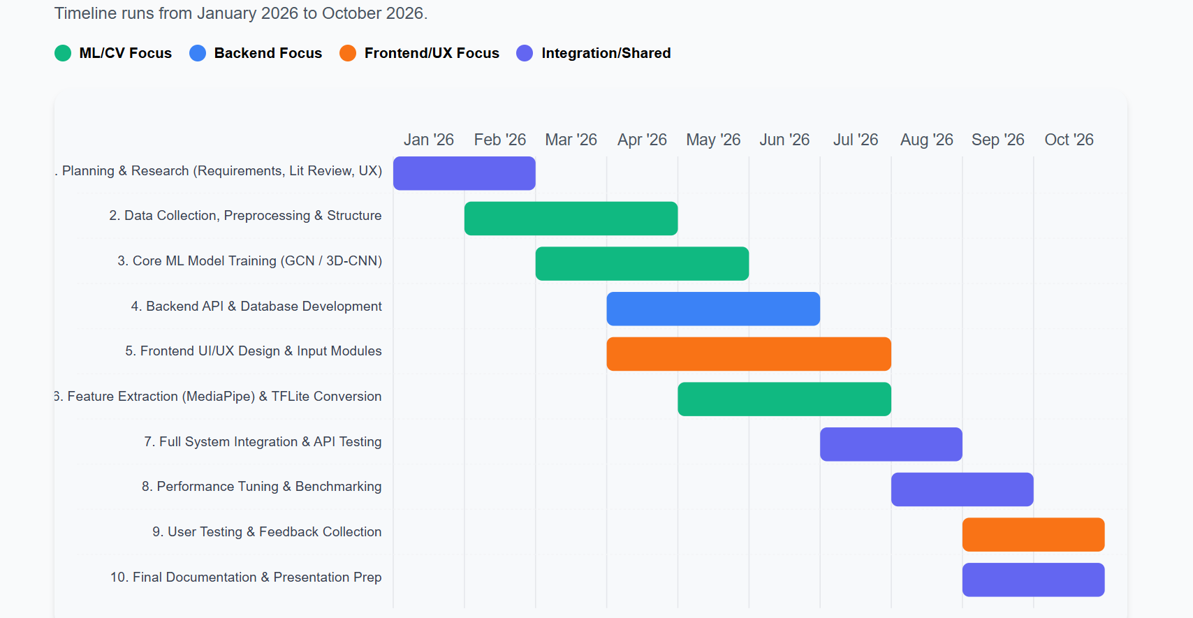

Figure 2. Project Gantt Chart (SignBridge FYP 2026)

8.Tools & libraries
  - Preprocessing & CV:
OpenCV, MediaPipe, OpenPose (research). MediaPipe+1
  - ML frameworks:
TensorFlow / PyTorch for training; TensorFlow Lite / LiteRT or PyTorch Mobile for on-device. TensorFlow
  - Backend & API:
FastAPI or Node.js (Express).
  - Mobile UI:
Flutter (cross-platform) or native Android/iOS if preferred.
  - Storage:
Firebase (Realtime / Firestore) or MongoDB for logs and optional user data.

Short note on risks & mitigations
- Data scarcity for local sign variants: mitigate by collecting a small labeled dataset (smartphone capture), use transfer learning and data augmentation.
- Latency or memory constraints on low-end devices: mitigate by aggressive model compression (quantization, pruning), delegate to cloud optionally, and use skeleton-only models when possible. TensorFlow
- Ethical/privacy concerns: keep on-device inference by default; only collect/upload user data with explicit consent.

9.References
1. D. Li, A. X. et al., “Word-level Deep Sign Language Recognition from Video: A New Large-scale Dataset and Methods Comparison,” WACV, 2020. CVF Open Access
2. N. C. Camgöz, S. Hadfield, O. Koller, H. Ney, and R. Bowden, “Neural Sign Language Translation,” CVPR, 2018. CVF Open Access
3. C. C. de Amorim, D. Macêdo and C. Zanchettin, “Spatial-Temporal Graph Convolutional Networks for Sign Language Recognition,” arXiv, 2019. arXiv
4. M. Alaghband et al., “A survey on sign language literature,” ScienceDirect, 2023. ScienceDirect
5. Google MediaPipe Hands / Hand Landmarker documentation. MediaPipe+1
6. R. Wong et al., “Sign2GPT: Leveraging Large Language Models for Gloss,” arXiv, 2024. arXiv
7. TensorFlow Lite (LiteRT) guides and model optimization pages. TensorFlow+1
8. RWTH-PHOENIX-Weather dataset (Koller et al.). www-i6.informatik.rwth-aachen.de

